

Peru Orientation Handbook

Table of Contents
Introduction to Global Missions’s work in Peru 3
Trip Costs 3
Sample Itinerary for Peru ……………………………………………………………………………….5
Cuzco Excursion Information ………………………………………………………………………….6
Sample Itinerary for Machu Picchu 7
Weather and Packing Information 8
Travel Safety 10
Packing
Travel Documents
Safely Handling Money
Cultural Sensitivity
Travel Health 11
Vaccinations
Malaria
Insect Borne Diseases
Food and Water Borne Illness
Medications
The Apothecare Pharmacy Travel Clinic at Porter Hospital

Power Outlets/Internet ………………………………………………………………………………13

Additional Reading . ……………………………………………………………………………………..14

Introduction to Global Missions’s work in Peru

Iquitos, Peru, deep in the Amazon Basin of Peru, is the largest city in the world with no road access. Since 2006, Global Missions has been working in Iquitos to provide support to our local partner hospital, Clinica Adventista Ana Stahl. The health care needs here are great, and services are limited and expensive for the local population. The barriers for most residents to see a doctor or utilize the few clinical services that are available are great. GLOBAL MISSIONS organizes the following projects in Peru:

1) Surgical Teams improve the surgical services at Clinica Adventista Ana Stahl in Iquitos by upgrading the OR and diagnostic equipment, conducting continuing education for surgeons and nurses, and providing free surgical services to patients who are unable to pay.

2) Community Health Teams address the basic health needs of the indigenous people living in villages along the Amazon River and its tributaries. This is done through primary health clinics which include education and prevention activities.

3) Community Service Teams (during summer trips only) work on service projects in villages along the Amazon. These teams are made up of non-clinical AdventHealth employees as well as children of medical volunteers.

4) Administration Teams are made up of AdventHealth leaders who travel to Iquitos to exchange ideas with the leaders at Clinica Adventista Ana Stahl.
______________________________________________________________________________

Trip Costs

Donation expectation:
Volunteers who participate in a Global Missions trip are required to make a tax-deductible donation to the project to cover the costs of the trip.
- $3,050 summer trips (May-August)
- $2,850 non-summer trips
- Donation Policy: As a tax-deductible donation, your trip commitment is non-refundable. Should you be unable to join the trip, all gifts given or solicited by you will still directly make an impact in the country and for the trip.

Costs covered by donated funds:
- Airfare
- Ground transportation
- Extra mission supplies bag fee
- Lodging
- 3 meals per day at clinic/hotel and Explorama (other dining is at your own expense)
- Medical Evacuation Insurance
  - PLEASE NOTE: Medical evacuation insurance from Adventist Risk Management is provided for each participant and covers the duration of the trip as outlined in this document. Any additional dates that you arrange separately outside of the published dates are not covered. Please inform the GLOBAL MISSIONS Travel Coordinator in writing if you have purchased alternative trip cancellation/evacuation insurance.
- Excursions: Lima and Belen tour (Time Permitting)
Note: The donation helps cover the expenses of Global Missions projects in Peru, including the travel expenses listed above. Specific expenses cannot be paid separately (i.e. airfare) - the donation is only managed in whole. Any exceptions must be approved by the Global Missions director.

Costs not covered by donated funds:
Immunization and personal medications (contact Porter Travel Health Clinic)
- Any personal needs and expenses
- Personal baggage overage fees
- Any meals eaten in-route (airports, etc.)
- Alcoholic beverages in Iquitos and purchased drinks at Ceiba Tops.
- Optional: Ceiba Tops/Amazon weekend. Cost is $375. This payment is not tax deductible.
- Optional: Cusco/Machu Picchu excursion. Cost approx. $1,500/person for double room occupancy. Rate depends on group size. Includes airfare between Lima and Cusco, and additional night/s in Lima. This cost is also not tax deductible.
NOTE: The Cusco excursion organized by Global Missions begins the Monday AFTER the Ceiba Tops weekend. If you want to go to Cusco you must also plan to go to Ceiba Tops unless you make separate arrangements for an individual trip. *If you cancel, a refund for the Machu Picchu excursion may not be available.
- Single room upgrade
- Spending money and tipping
-Tipping of baggage handlers at the airport or hotel (usually $1 per bag)

The Lima airport has a place to exchange money for local currency. The exchange rate varies so check the current rate at the time of departure. The most convenient place to exchange is at the airport and it is the safest. It is not advised to change money on the street.

For people traveling elsewhere after the mission week
If you plan to fly to a destination other than Denver on the way home, Global Missions will invoice you for the difference in airfare. For example, if the average ticket for the group from Denver to Lima and back is $1300 but you go to Ecuador on the way home and your round-trip ticket is $1700, then you will be invoiced for the extra $400. We strongly recommend that volunteers travel with the group on the way to Lima. This helps to maximize the safety and efficiency of the team with issues such as international logistics, customs, and the transportation of supplies.

Sample Itinerary for Peru

Date Schedule

Friday Fri AM - Depart Denver
Fri PM - Arrive Lima
Transfer to Antigua Miraflores hotel

Saturday Sat AM Explore Miraflores
Sat PM Depart for Iquitos
Transfer to Hotel Victoria Regia
(http://www.victoriaregiahotel.com/)

Sunday Organization Day
CHT organizes supplies, Surgery Team screens patients
Tour of Iquitos time permitting
Full group: Night at Victoria Regia

Monday Service Projects
Surgery Team: Night at Victoria Regia
Community Health Team: Transfer to Explorama Lodge

Tuesday Service Projects
Surgery Team: Night at Victoria Regia
Community Health Team: Night at Explorama Lodge

Wednesday Service Projects
Surgery Team: Night at Victoria Regia
Community Health Team: Night at Explorama Lodge

Thursday Service Projects
Community Health Team transfers back to Iquitos
Group dinner at Clinica Adventista Ana Stahl
Full group: night at Victoria Regina

Friday Last day
Those returning home after the mission week depart
Amazon Excursion group transfers to Ceiba Tops Lodge
(http://www.explorama.us/ceibatopslodge.shtml)

Optional Ceiba Tops Weekend

Saturday Free Day
Excursions or relaxation
Night at Ceiba Tops Lodge

Sunday Free Day
Excursions or relaxation
Afternoon boat ride back to Iquitos
PM flight to Lima
Overnight at Holiday Inn

Monday Travel Day
AM flights to Denver via Panama City or to Cusco

Family Trips and College-Age Participants

Family trips are organized during the summer months. Children ages 12 and up are encouraged to participate with their parents. If you are a volunteer between the ages of 18-22 and are traveling without a parent, please know that we will require some extra information from you as well as an interview before we can approve your application.

PLEASE NOTE: If you are in medical or nursing school but have not yet graduated, please know that you will not be able to serve in a medical capacity. You may be able to observe our working physicians and nurses but that will depend on the make-up of the team and the team leader’s decision. Non-clinical positions are open for volunteers in undergraduate or graduate programs, but no clinical work can be done without a license.

Cusco Excursion Information

- Optional: Cusco/Machu Picchu excursion. Cost approx. $1,500/person for double room occupancy. Rate depends on group size. Includes airfare between Lima and Cusco, and additional night in Lima, ground transportation, hotels, all breakfasts, one lunch, one dinner, train to Machu Picchu, entrance fees to Machu Picchu and other ruins, tour guides.

- You will be hosted by Francisco of Latino Tours- Global Missions has a long history and friendship with Francisco and I hope you all enjoy his company as well as his passion and impressive knowledge of the history of the Incas. You will be traveling to see Machu Picchu, but you will also get the chance to explore other lesser known (though no less impressive) ruins in Ollantaytambo, Pisac, and Cusco. This tour will be a chance for you to learn about the important history of this region of Peru and its people, do some great shopping (alpaca hats, sweaters, and scarves make great gifts), and sample some unique regional cuisine (including Guinea pig!)

- Global Missions will pay Latino Tours in advance for all costs of this tour.

- Breakfast is included at each hotel. There are two other meals which are included in the cost of the excursion- a lunch at Machu Picchu, and a dinner show the final night in Cusco. All other meals are the responsibility of each participant. Francisco can recommend some great restaurants, or you can choose to explore a bit on your own.

- Tips are also not included in the cost of the excursion. Note that you can either tip in Soles or dollars- it’s helpful to get a stack of $1’s and $5’s to bring down for tips!

Please make sure that you provide clean crisp bills when tipping. Torn or worn bills are unusable to the local people, and it is considered an insult to receive them.

Sample Itinerary for Cusco/Machu Picchu

Date Schedule

Sunday Travel Day
Transfer to Hotel in Lima

Monday Excursion Day 1
AM- Depart Lima
PM- Arrive Cusco
Transfer to Ollantaytambo
Night at Pakaritampu Hotel
(http://www.pakaritampu.com/)

Tuesday Excursion Day 2
AM: Train to Machu Picchu
Tour and lunch at Machu Picchu
PM: Train back to Ollantaytambo
Night at Pakaritampu Hotel

Wednesday Excursion Day 3
Morning tour of Ollantaytambo
Afternoon visit to Pisac and llama reserve
Transfer to Cusco
Night at Los Portales Hotel or similar alternative
(http://www.losportaleshoteles.com.pe/)

Thursday Excursion Day 4
Morning walking tour of Cusco
Afternoon visit to Sascayhuaman
Night at Los Portales Hotel

Friday Excursion Day 5/Travel Day
Morning free time to further explore Cusco
Evening flight to Lima
Overnight in Lima

Saturday Travel Day
AM departure from Lima early evening arrival in Denver

Weather and Packing Information

Lima's weather and climate isn't what one would expect when travelling to a city located just 12° south of the equator. It's usually described as mild and warm throughout the year without noteworthy rain, making Lima one of the driest capitals in the world. The average temperatures range from 54°F to 64°F (low) and 75°F to 82°F (high). Relative humidity is very high and produces quickly passing morning fogs from December to April and persistent low clouds and mist from May to November. Sunny, moist and warm summers (December - April) are followed by cloudy, damp and cool winters (May - November). http://www.limaeasy.com/lima-info/the-weather-and-climate-in-lima

Iquitos has a unique climate in comparison to the rest of Peru’s Jungle regions. Temperature and rainfall in this area remain relatively constant throughout the year, with the rainfall increasing slightly during the months of November to April and decreasing during June, July and August. Highs can reach 91°F during the day and can fall as low as 71°F during the night. Although the weather in Iquitos stays roughly uniform thought the year, it is important to know that there are also high and low water seasons. Water levels can rise by an incredible 23 feet towards the fall of each year (April/May) as higher levels of precipitation and melting snow from the surrounding mountains envelop the Amazon River Basin. http://theonlyperuguide.com/peru-guide/amazon-jungle-peru/weather-in-the-amazon-jungle/

Since Iquitos is in the Peruvian rainforest, and typically hot, humid, and rainy year round; it’s therefore important to pack light clothes that will dry quickly. Short sleeved shirts are ok during the day, but in the evenings long sleeved clothing will help to discourage mosquitos and other biting bugs. Likewise, shoes (rather than sandals) are recommended. A lightweight rain jacket is a must.
As health care professionals and as representatives of AdventHealth, dress and decorum should be appropriate, however, the hot and humid weather in Iquitos means that suits and neckties are not normally worn. Jeans, shorts, t-shirts, and other casual clothing are acceptable during the optional tourist excursions.

Cuzco’s daily average temperatures are usually constant. Climate-Charts.com notes that the average daily high is approximately 70°F with little seasonal fluctuation. These higher temperatures are reached during the daytime. The lower end of the temperature scale is more capricious. From mid-October to mid-March, the average daily low is about 43°F. The lowest temperatures occur from the end of March until mid-September, falling as low as 32°F. These lows occur at night during Peru's winter. While Cuzco’s winter daytime temperatures remain around 70°F, the temperature drops significantly as soon as the sun sets. Cuzco's rainy season generally starts in October or November and lasts until April or May. The period from May until the end of September is the dry season (which is also Cuzco’s high season for tourism). Despite lower nightly temperatures, the dry season has more sunshine and less precipitation. Heavy rain showers do occur during the dry season but rarely last for more than an hour. http://traveltips.usatoday.com/climate-cuzco-peru-54822.html

For those traveling on to Cusco, a fleece or jacket is recommended.

Time

Denver is 1 hour behind Peru or 2 hours behind during daylight savings time.

Packing/Airport
- 2 checked bags weighing no more than 50 lbs each and no larger than 62 total inches each. 1 checked bag is for group supplies obtained at the packing party and the other checked bag is for personal belongings.
- 1 carry-on bag weighing no more than 20 lbs and no larger than 45 total inches
  - Carry-on rules: no liquids more than 3 oz, sharp objects must be packed in checked bags
- 1 personal item (purse, camera bag, small back pack, etc.).
  - Note: this does not mean another carry-on size bag
- Personal equipment (ex. stethoscopes)
- Personal valuables (computer, cameras, etc.)
  - Pack all of these in your carry-on
  - If you won’t use it, don’t take it
- You will put colored tape on your medical supplies luggage to make them easy to spot. Help each other to collect luggage on the belt.
- Please respect others; always be on time for scheduled events (better early than late).

Documents | Clothing
- Passport MUST NOT EXPIRE FOR SIX MONTHS AFTER ARRIVAL IN PERU | - Quick dry pants and shirts
- Photocopy of Passport | - Long sleeved shirts (for evenings)
- Health Documentation | - Lightweight rain jacket
- Copies of all Plane Tickets | - Comfortable shoes
- Cash (new, crisp bills) | - One professional wardrobe
- Credit Cards | - Jeans/khakis/shorts
 | - Underwear and socks
 | - Swimsuit
 | Hat or sun visor
 | - Sweater and or/fleece (for Cusco)
 | - Scrub pants for the OR
 | - Clothes for dinners out in Iquitos
Other Basics | Toiletries
- Sunglasses | - Brush/comb
- Travel umbrella | - Shampoo/conditioner
- Alarm clock | - Deodorant
- Flashlight | - Makeup/moisturizer
- Ziploc bags | - Toothbrush/toothpaste
 | - Shaving kit
Medications | Miscellaneous
- Insect repellant | - Money belt/pouch
- Sunscreen/lip balm | - Camera /batteries
- Malaria pills | - Binoculars
- Personal prescriptions | - Electrical converter/adaptor
- Personal hygiene items | - Snack food
- Band aids | - Books
- Aspirin/pain reliever | - Writing materials
- Diarrhea medicine
- Hand wipes/sanitizer

Travel Safety

The U.S. Department of State’s website on international travel contains useful travel safety tips, contacts, country information, and emergency information. This is a great resource to explore before your trip.
- Travelers Checklist
http://travel.state.gov/content/passports/english/go/checklist.html

Peru is a relatively safe location, although travelers should always be attentive. The following tips will help you remain safe and healthy during your trip.

Packing
While packing, think hard about what to bring, and what to leave behind. Don’t bring along anything that you wouldn’t want to lose, including valuable jewelry, irreplaceable items, and extra credit cards.

Travel Documents
A valid US passport is required for travel to Peru. Your passport must have six months validity at the time of entry into Peru. Other important documents to bring include:
- Color copies of your passport
- Immunization records
- Copies of your trip itinerary and any hotel or travel reservations
- Copies of credit cards and ID
- Proof of COVID-19 Vaccination

Remember to leave an itinerary, contact phone numbers, and passport copies with a family member or friend back home.

Safely Handling Money
Before you leave, be sure to notify your bank of your travel plans. Be aware and smart about displaying money and making transactions in the developing world. Try not to display large amounts of cash, and separate out large from small bills, so you can quickly grab what you need.
A money pouch, which goes under your clothes, is highly recommended for international travel.

It’s also smart to separate your money sources. Do not carry all of your credit cards and cash in one place- if this gets stolen, you’ll be left with nothing. Separate credit cards and cash between several safe locations.

Cultural Sensitivity
You will be confronted with a very different culture in Peru. Keep an open mind, be respectful, and take this opportunity to learn about a different way of life. Be aware of your actions and how they might be portrayed by another culture.

Remember that you are traveling to Peru as a healthcare professional and a representative of AdventHealth, dress and decorum should be appropriate.

Food and Drink
One of the adventures of travel is trying new foods. GLOBAL MISSIONS does its best to provide food that is safe to eat. Food at the hotel, restaurants and hospital should be safe, but always be careful. Eating from street vendors can be risky.
- A rule of thumb is to never drink water from the tap (always drink bottled water). Don’t eat food that is uncooked or not peeled.
- GLOBAL MISSIONS will provide you with plenty of safe drinking water during the week.

No Solo Traveling
Do not go out on the streets by yourself. Always travel in pairs or a small group.

Travel Health

Staying healthy while in Peru will be very important. We want all of our volunteers to be at the top of their game to ensure we’re able to fully maximize our resources while on the ground! The CDC provides a good overview of health information for Peru.
- Health Information for Travelers to Peru
http://wwwnc.cdc.gov/travel/destinations/traveler/none/peru

https://www.porterhospital.org/poh/specialties/outpatient-services/travel-health-clinic/
  - For additional information regarding Tuberculosis and Zika, please see the following CDC resources:
  - https://www.cdc.gov/tb/publications/factsheets/general/travelinfo.pdf
  - https://www.cdc.gov/mmwr/volumes/66/wr/mm6613e1.htm

Vaccinations
The following vaccines are recommended for travel to Peru
- Hepatitis A
- Hepatitis B
- Typhoid
- Yellow Fever
- Routine Immunizations: tetanus-diptheria, MMR, polio, varicella
- COVID -19

Malaria
Malaria is a risk in Iquitos, and it is recommended that all travelers to Iquitos take medications to prevent malaria. There are several options for malaria prevention. The CDC page below provides a comparison of the different medications available. Your doctor can prescribe this.
- Malaria prophylaxis recommended
  - Choosing a Drug to Prevent Malaria http://www.cdc.gov/malaria/travelers/drugs.html
- DEET and proper clothing

Insect Borne Diseases
A DEET- based insect repellent will help keep the bugs away. 100% burns skin, 30% is fine. You can also treat clothing with Permethrin, or buy treated clothing at an outdoor store like REI.

Food and Water Borne Illness
Food and water borne illnesses are a common concern of travelers to the developing world. It’s important to only drink filtered water and be cautious of the foods you eat- for example, raw vegetables and fruit washed in untreated water could cause illness.

Medications
- Prophylactic treatment for traveler's diarrhea
- Bring sufficient quantities of personal prescription medication, antihistamine, antacid, anti-diarrhea, antibiotic topical cream, anti-nausea medication

If you take any medications, pack enough for your entire trip and extra in case of delays. Carry all medications in their original containers with labels. You may want to bring a note from your doctor in case you are questioned about your medications at the airport.

Passport Health

Passport Health provides full immunization services, information about your specific itinerary, recommendations for prescriptions to prevent malaria and traveler’s diarrhea, contact phone numbers for consulates, embassies, and hospitals, and more. Please call 303-442-8728
for an appointment.

Walgreens/Costco
Vaccinations can also be ordered from your local pharmacy.

*** Check your health insurance for coverage. ***

Power, outlets, electricity & internet

In most areas, you will need a voltage converter and plug adapter in order to use U.S. electronics. Voltage is usually 220 volts and if your device is not designed for that it will burn out immediately. The plug might not be the American style and will most be likely the two round prong-style (seen in continental Europe). There are no 3-prong plugs, so you might need a three-two adapter as well. Some hotels may have both options of outlets.

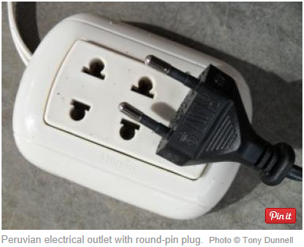

Wi-Fi is available in all hotels but is not very reliable. It often depends on where you are in the hotel and how many other people are trying to get online. At Ceiba Tops Lodge wi-fi is not available in your room, only in the main building. At the Victoria Regia wi-fi is available throughout the hotel but signal strength varies. Usually the lobby is the best bet. There is wi-fi at Clinica Adventista Ana Stahl.

Additional Reading

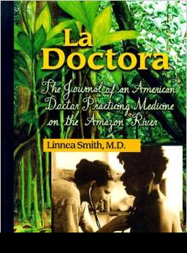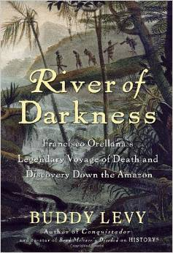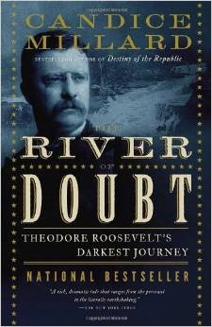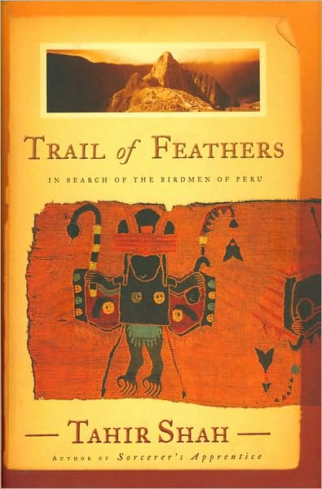

A physician from Wisconsin, Dr. Linnea Smith, has been working in the jungle area near Iquitos for several years. She has written a book called La Doctora that provides some excellent information about the area and the challenges of providing medical care to a population that is uncertain about the benefits of western medicine.

River of Darkness by Buddy Levy tells about the first Europeans who traveled down the Amazon River and saw the local inhabitants before disease and destruction came to the region.

The book River of Doubt by Candice Millard tells the journey of Theodore Roosevelt and his son down an unexplored tributary to the Amazon River in Brazil, and how he almost died in the jungle.

Trail of Feathers by Tahir Shah is an entertaining story about his search for the "birdmen" of Peru. A major portion of this book takes place in the jungles around Iquitos.

If you have a special interest in Machu Picchu, here are some books written by Boulder residents, Ken and Ruth Wright: The Machu Picchu Guidebook and Machu Picchu Revealed. Another good book by Mark Adams is Turn Right at Machu Picchu.

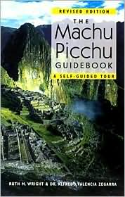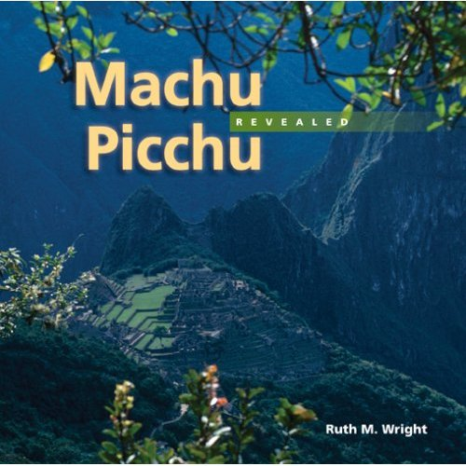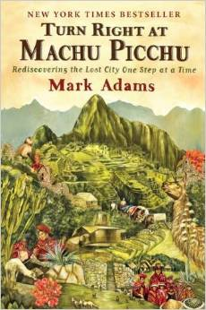

If you want to learn more about Peru, you can look at the following Web sites:
www.go2peru.com (government tourist office)
www.lonelyplanet.com/destinations/south_america/peru (Lonely Planet's Web site)
www.state.gov/r/pa/ei/bgn/35762.htm (State Department)
For good reading about individuals who have made an impact in the world, the following books are also good reads: Mountains Beyond Mountains, the story of Dr. Paul Farmer’s work in Haiti, Peru, Russia, and the WHO; The Blue Sweater, the story of Jacqueline Novogratz and her work to develop sustainable change in the developing world; and Leaving Microsoft to Change the World, the story of John Wood, founder of “Room to Read.”

